ACCESSIBILITY TO ELECTRICITY (%TOTAL POPULATION) 1990 AND 2010

*Securing a reliable and sustainable electricity services is a key aspect in many countries of the world, more countries are beginning to look inwardly onto other area to generate electricity. Energy is very important to help humanity and for economic sustainability. Access to it is very crucial for basic activities like cooking, refrigeration, industrial use and improving technology in the country. For this assignment, two major python libraries were employed for the wrangling and visualization of the dataset used. Data was extracted from the* ***World Bank Data*** *and we also visualized three (3) Asian countries which are against electricity distribution in the world.*

**Insights from the Analysis**

The datasets used for this assignment were sourced online from the World Bank and GitHub, respectively. The dataset obtained from the World Bank website contained 20,216 observations (rows), while the dataset obtained from GitHub had 249 records. Upon cleaning and merging of the two dataframes, 21 years records for Accessibility to Electricity and Total population between 1990 and 2010 were chosen and worked on for the purpose of this assignment. Here, we found the number of records (within the specified years) to be 3493. Next, the data was grouped by year and country.

Upon grouping by year, we found the minimum, maximum, and average values for percentage of population withaccess to electricity to be 76.27%, 95.80%, and 81.24 respectively. Next, we checked the top-3 years when access to electricity was highest. The years are: 1990, 1991 and 1992 respectively.

Furthermore , we checked for the correlation between the variables (access to electricity (% of population) and population (total)), here, we found that per unit increase in population (100, 000), there is a drop in access to electricity by 42%.

Upon grouping by country, we found the minimum, maximum, and average values for to percentage of population with access to electricity to be (4.08%, 100.00%, and 78.62%) respectively. Next, we checked the top-3 countries with access to electricity. The countries areAlbania, Andorra, and Australiawith 100%

of the population having access to electricity.

From the analyses, we found that population is on the rise over the years (there were drops in some years though), while access to electricity declined steadily from year 1990 until around year 2002 when it starts increasing i.e., more people start having access to electricity. We can infer from this that electricity generation has increased incredibly from year 2002 upward.

**Data exploration**

We first import the data by Loading it from then world bank and display the first 5 rows of the data to give us what to explore, then we carry out some functions and we found that we have 20,1016 rows and 66 columns in the data frame. Many insights cannot be drawn from the summary statistics table presented in the data used. We did cannot identify the indicator whose summary corresponds with the output result above. We now limit the years under study to contain only records from year 1990 to year 2010.

**Data groupings**

In data grouping, we group the data frame by two metrics; **year**, **country name**. This will afford us the opportunity to draw some insights from the created data frame.

**Visualization**

We start by visualizing the final extracted data for the Arable land and forest areas based on indicator chosen.

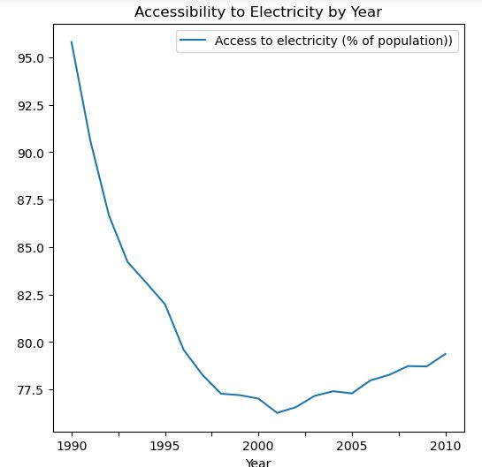

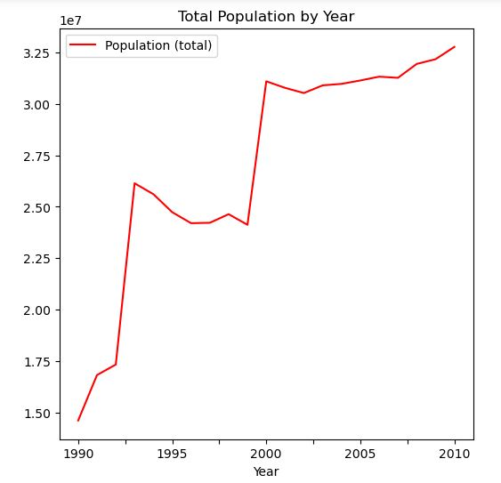

The above bar chart shows the level of progress that when the data is grouped by year, there will be 83.05% reduction in the percentage of population that had access to electricity as total population (100,000) increases.

The chart below shows the number of occurrence of arable and forest area by year and the population.

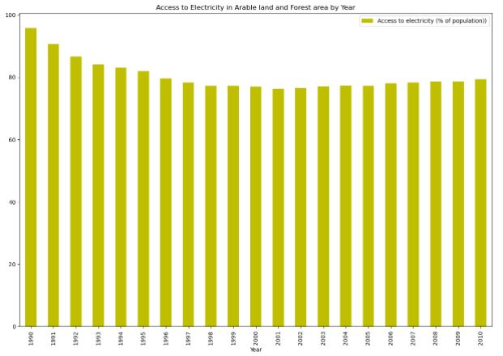

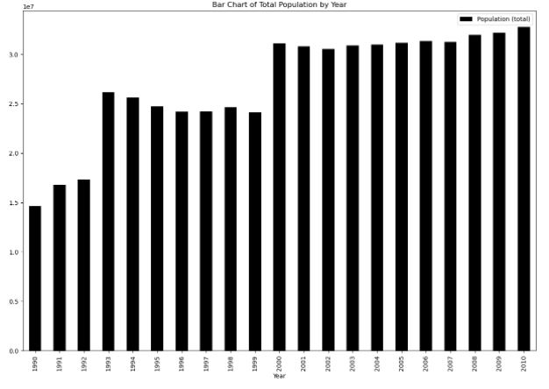

We deduce from the above chart, that when the data is grouped by country, there will be an increment by about 2% when total population increases.

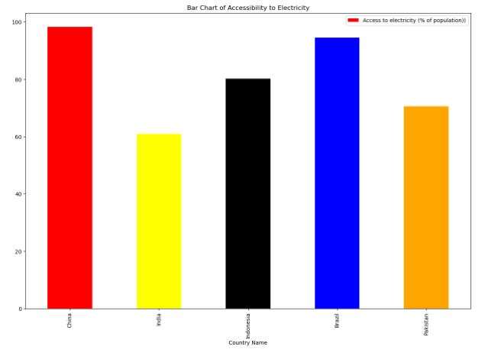

The above show the accessibility of electricity of the Asian countries which are China, Indian, Indonesia, Brazil and Pakistan.

**Accessibility to electricity in china**

The horizontal bar plot presents the electricity in china alongside the years

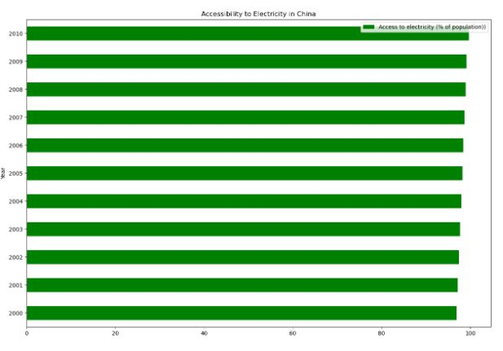

**Accessibility to electricity in India**

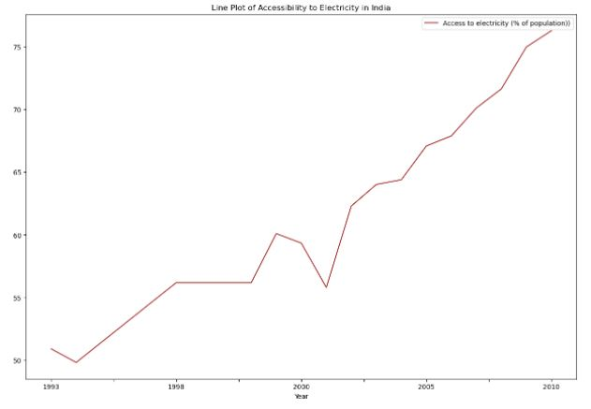

From the above chart, we observed that in India, the percentage of population that has access to electricity has continued to increase over the years, except in years 1994, 1998, and 2002 where there were noticeable drops. A closer look at the population indicates that China has been doing incredibly well in meeting the electricity needs of people living in the country.

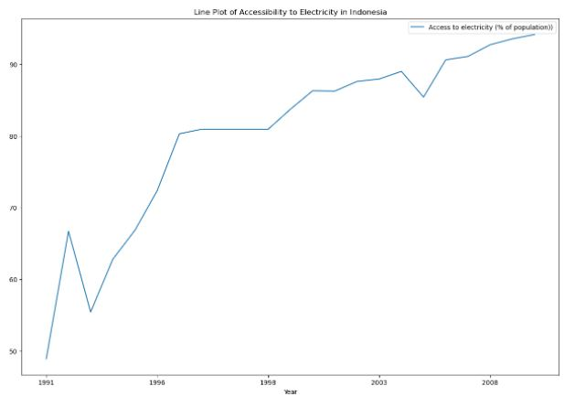**Accessibility to electricity in Indonesia**

From the above chart, we observed that in Indonesia, the percentage of population that has access to electricity has continued to increase over the years, except in years 1993, 1999, and 2006 where there were noticeable drops. A closer look at the population indicates that China has been doing incredibly well in meeting the electricity needs of people living in the country.

The result of the correlation analysis shows that per unit increase in population (100, 000), there is an increase in the percentage of population that has access to electricity by 89.51%.

**Conclusion**

In conclusion, accessibility of the population in a country helps in the growth and development of that country. When grouped by countries their where 2% increase but When we visualize the selected countries in Asia we can see that China have been doing extremely well in improving the electricity of their country based on the population. The result of the correlation analysis in China shows that per unit increase in population (100, 000), there is an increase in the percentage of population that has access to electricity by 98.15%. Which is higher compared to India and Indonesia.